Practical No 28, 29 & 30

VIII. Resources required (Additional)
→ If any web resources required.

Resources used (Additional)
https://www.tutorialspoint.com/vb.net/vb.net

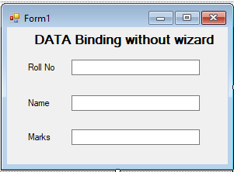Program Code
  - Write a program using data binding in VB.Net
➢

Imports System.Data.OleDb


Public Class Form1
Private Sub Form1_Load(sender As Object, e As EventArgs) Handles MyBase.Load Dim con As OleDbConnection
Dim ds As New DataSet
Dim cmd As OleDbCommand Dim da As OleDbDataAdapter

con = New OleDbConnection("Provider=Microsoft.Jet.OLEDB.4.0;Data Source=C:\Users\Suresh\Documents\Visual Studio 2012\Projects\Data binding\Student.mdb")
con.Open()

cmd = New OleDbCommand("Select * From student", con) da = New OleDbDataAdapter(cmd)
da.Fill(ds, "student")

TextBox1.DataBindings.Add("Text", ds, "student.Roll_No") TextBox2.DataBindings.Add("Text", ds, "student.Name") TextBox3.DataBindings.Add("Text", ds, "student.Marks")

End Sub End Class

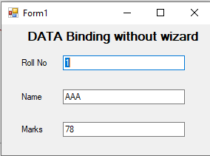Output:

Practical related Questions
  - Write syntax of simple binding for text box.
- TextBox1.DataBindings.Add(“Text”, Dataset11, ”table.empid”)

Write a syntax of complex binding for combo box.
- ComboBox1.DataSource=ds.Tables(“table_name”) ComboBox1.DisplayMember=”field_name”

Exercise
  - Design a windows application for student name and college name using a simple data binding use appropriate database.

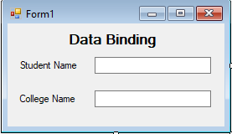
➢
Imports System.Data.OleDb
Public Class Form1

Private Sub Form1_Load(sender As Object, e As EventArgs) Handles MyBase.Load
Dim con As OleDbConnection Dim ds As New DataSet
Dim cmd As OleDbCommand Dim da As OleDbDataAdapter
con = New OleDbConnection("Provider=Microsoft.Jet.OLEDB.4.0;Data Source=C:\Users\Suresh\Documents\Visual Studio 2012\Projects\student data binding\db1.mdb")
con.Open()

cmd = New OleDbCommand("Select * From Student", con) da = New OleDbDataAdapter(cmd)
da.Fill(ds, "Student") TextBox1.DataBindings.Add("text", ds, "Student.Name")
TextBox2.DataBindings.Add("text", ds, "Student.College") End Sub
End Class

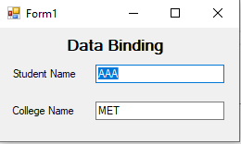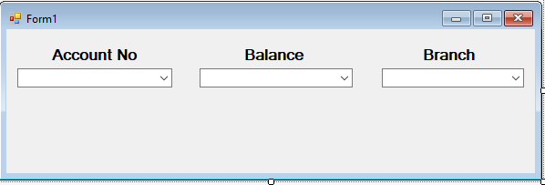OUTPUT:

  - Design a windows application for bank customer record & display it using Complex data binding use appropriate database.
➢

Imports System.Data.OleDb Public Class Form1

Private Sub Form1_Load(sender As Object, e As EventArgs) Handles MyBase.Load

Dim con As OleDbConnection Dim ds As New DataSet
Dim cmd As OleDbCommand Dim da As OleDbDataAdapter

con = New OleDbConnection("Provider=Microsoft.Jet.OLEDB.4.0;Data Source=C:\Users\Suresh\Documents\Visual Studio 2012\Projects\Bank Customer Record\db1.mdb")
con.Open()

cmd = New OleDbCommand("Select * From Bank_Details", con) da = New OleDbDataAdapter(cmd)
da.Fill(ds, "Bank_Details")

ComboBox1.DataSource = ds.Tables("Bank_Details")

ComboBox2.DataSource = ds.Tables("Bank_Details") ComboBox3.DataSource = ds.Tables("Bank_Details")

ComboBox1.DisplayMember = "Acc_No" ComboBox2.DisplayMember = "Balance" ComboBox3.DisplayMember = "Branch"

End Sub End Class

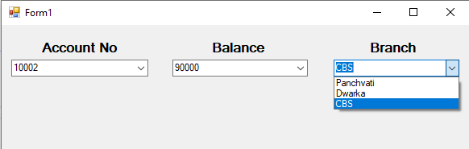
OUTPUT:

